# CREATION OF DATABASE

#Author: Sudip Prajapati

#Date: 2021/11/09

## TASK DONE:

* Creation of three tables: Student , Course ,Teacher
* Inserting of three records in each table
* Showing of the created reach table records
* Update of each table records With its results
* Deleting the records

**Creation of Database**

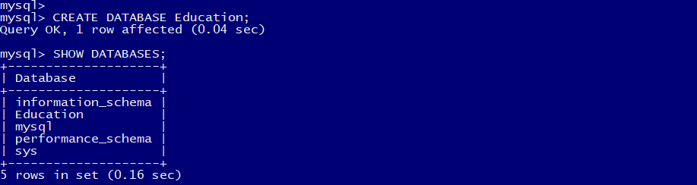

Figure 1: Creation of Database Education

## CREATION OF THREE TABLES

* **TABLE Student;**

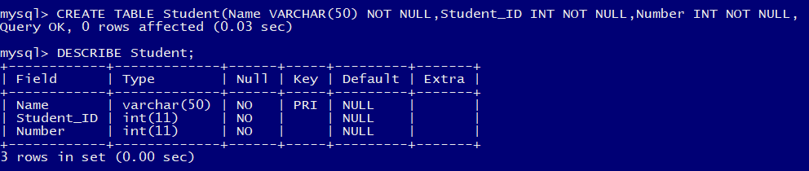

Figure 2: Creation of Table student

* **TABLE Course;**

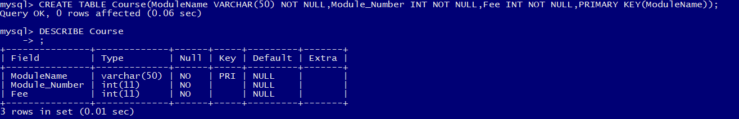

Figure 3: Create table course and describe

* **TABLE Teacher;**

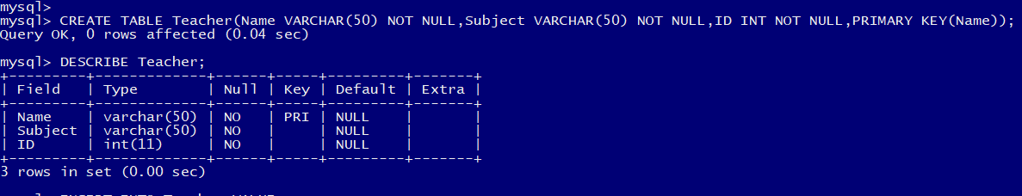

Figure 4: Create and describe table teacher

## INSERTING OF THREE RECORDS IN EACH TABLE

* **TABLE Student;**



Figure 5: Insert value in student table



Figure : Insert value in table student



Figure : Insert value in table student

* **TABLE Course;**

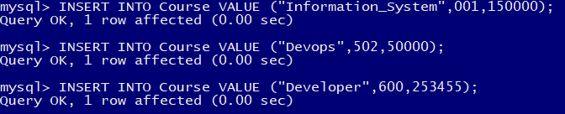

Figure 8: Insert Value in course table

* **TABLE Teacher;**

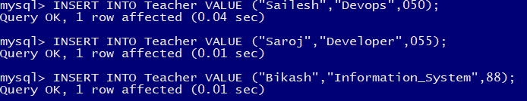

Figure 9: Insert value in table teacher

## SHOWING THE CREATED REACH TABLE RECORDS

* **TABLE Student;**

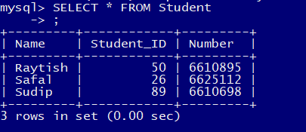

Figure 10: Student table

* **TABLE Course;**

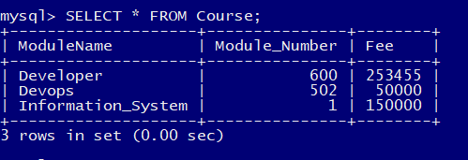

Figure 11: Table Course

* **Table Teacher;**

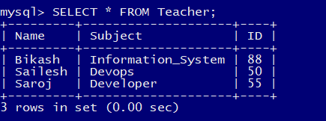

Figure 12: Table Teacher

## UPDATE OF EACH TABLE RECORDS And ITS RESULTS

* **TABLE Student;**

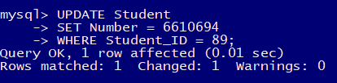

Figure 13: Update process of student table

UPDATED STUDENT TABLE:

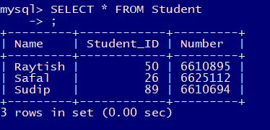

Figure 14: UPDATED Student table

* **TABLE Course;**

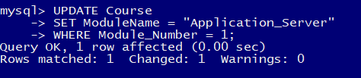

Figure 15: Update process of table course

UPDATED Course Table:

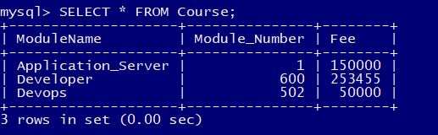

Figure 16: Updated Table Course

* **TABLE Teacher;**

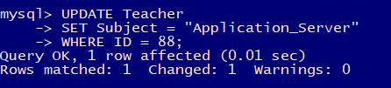

Figure 17: Update process of table Teacher

UPDATED Teacher TABLE:

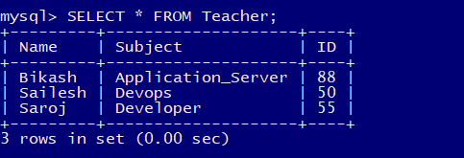

Figure 18: Updated Table Teacher

# DELETE RECORDS

## Deleting Student Record;



Figure : Delete record of Student table

## SHOWING THE TABLE TO PROVE THAT ONE OF THE STUDENT TABLE RECORD IS DELETED FROM THE TABLE

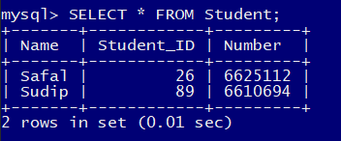

Figure : Showing the available tables